- List 3 key differences between Ethernet cables and fiber optic cables, and give one real-world example where each type would be used (for example, home WiFi router, data center, college campus backbone).
Ans :-
Feature | Ethernet Cable | Fiber Optic Cable
1. Signal | Uses electrical signals. | Uses light signals.
2. Speed and distance | Good for high-speed connections over shorter distances. | Supports very high speeds over long distances.
3. Cost | Usually cheaper and easier to install. | Usually more expensive and requires special tools.

- Draw and label a diagram showing the internal wiring of a straight-through Ethernet cable (use T568B wiring standard), indicating the color of each wire and its pin number.
Ans :- A straight-through Ethernet cable uses the same wiring standard (T568B) at both ends of the cable.
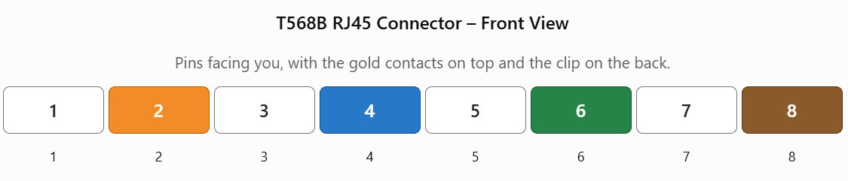
Pin numbers and wire colors
Pin | Wire color
1 | White/Orange
2 | Orange
3 | White/Green
4 | Blue
5 | White/Blue
6 | Green
7 | White/Brown
8 | Brown

- Watch a YouTube video demonstrating how to use an RJ45 crimper, then write a step-by-step guide (in your own words) on how to attach an RJ45 connector to a CAT6 cable.
Ans :-
Step 1: Cut and strip the cable
Cut the CAT6 cable to the required length. Carefully remove about 2–3 cm of the outer jacket without damaging the inner wires.
Step 2: Arrange the wires
Separate the eight small wires and arrange them in the T568B color order
Step 3: Trim and insert the wires
Straighten the wires, trim their ends evenly, and insert all eight wires into the RJ45 connector. Make sure they reach the front of the connector and the cable jacket extends inside it.
Step 4: Crimp the connector
Place the connector into the RJ45 crimping tool and squeeze the handles firmly to secure the wires and contacts.

Step 5: Test the cable
Use an Ethernet cable tester to check that all eight wires are connected correctly. Repeat the same T568B wiring process at the other end to make a straight-through cable.
- Safety tip: Use the cutting and crimping tools carefully, and avoid cutting the small internal wires while removing the outer jacket.

- Imagine you are setting up a gaming café with 10 PCs for LAN gaming. Decide which cable type (Ethernet or fiber optics) and which tool (RJ45 crimper or fiber cleaver) you would use, and explain your choices in 3-4 sentences.<br><br><em><strong>Hint:</strong> Consider speed, distance, and budget for your answer.</em>
Ans :- I would choose CAT6 Ethernet cables and an RJ45 crimping tool for connecting the 10 gaming PCs. CAT6 supports high-speed, low-latency connections suitable for LAN gaming, and it is affordable for a small café. The RJ45 crimping tool is used to attach connectors to the cables, making custom-length network cables. Fiber optics and a fiber cleaver would generally be unnecessary for connecting PCs within a small café because fiber equipment costs more and is better suited to longer-distance links.

